**Group 20**

**Participants**:

Bait Yash Sudhakar AP18110010423

Paladugula Uday Kishore AP18110010455

Chirumamilla Chakradhar AP18110010443

**DBMS Project Report**

**Title:**

Covid-19 potential test candidates’ identification and data base management

**Synopsis:**

Project title: Covid-19 potential test-candidates identification and data base management

Aim/Objective:The aim of the project is to make fully functional website that identifies users with potential risk of Covid-19 infection based upon the user's answers to the questions displayed on the websites and prompts the user to take necessary steps and precautions. The data of these users is stored in the database. This will ease the municipality's job of identification of the contention zones in their area.

Technologies used: MySql Workbench, SQL(for DBMS), HTML,CSS, JAVASCRIPT(for the front-end of the website).

Assumptions taken: There will be potential patients of the novel disease who will generate data which will be collected and which in-turn can be used to spot “containment zones”. The data will also help in providing valuable insights for the current situation.

Details handled:Users’ data such as past history of illness in the family, address, symptoms, whether patient tested positive, display of nearby hospitals and testing centres.

Sample scenarios:

Scenario: The user opens the website for the first time, the user is prompted to create an account. Once the user logs in as a registered user, they are prompted to answer a few basic questions, to which, the users’ answers are recorded and analysed. Based upon the analysis of the users’ answers, the users are told whether they or their family members should visit the nearest health-centres for the testing of Covid-19. Based upon the result of the test, the user is asked to take the necessary steps. The health centre at which the patient is admitted stores their data. This data provides valuable insight into the present situation of the ongoing pandemic.

Who can use this application in real life:

Primary usage: The application as well as the insights provided by the data obtained from the website can be used by health care industries and the government to come up with solutions and measures to bring the current situation under control efficiently.

The application also provides an online guide for the people who think that they are at the risk of contracting the disease. The website will guide them about the steps to be taken like going for the check-up if certain symptoms appear.

**Project flow:**

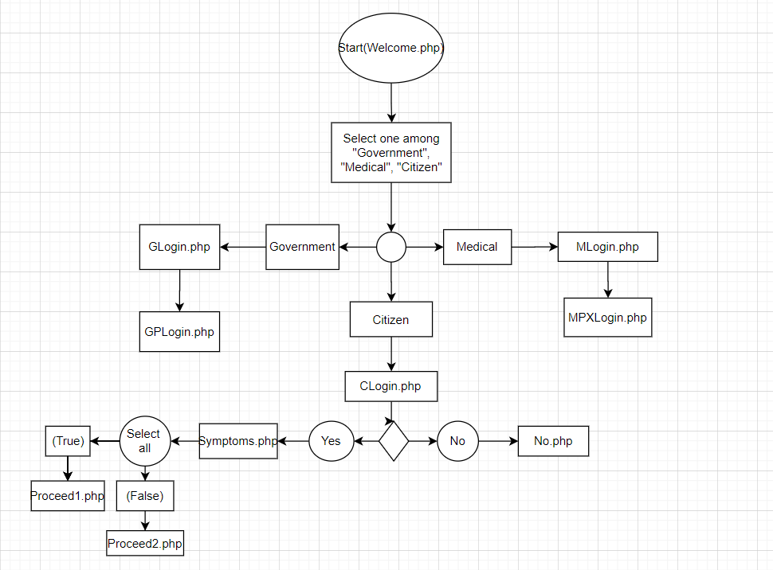

ER diagram:

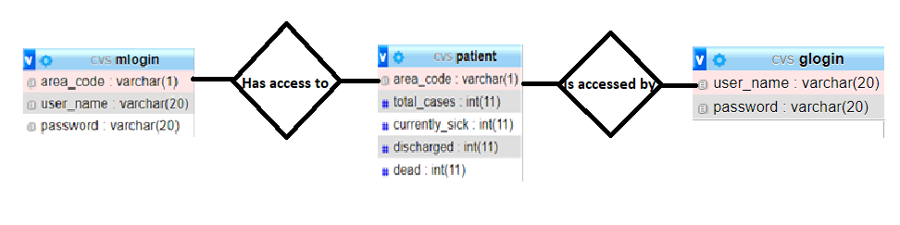

**Conclusion:**

As stated earlier, the main aim of the project is to make fully functional website that identifies users with potential risk of Covid-19 infection based upon the user's answers to the questions displayed on the websites and prompts the user to take necessary steps and precautions. The data of these users is stored in the database. This will ease the municipality's job of identification of the contention zones in their area.

We have assumed that there will be potential patients of the novel disease who will generate data which will be collected and which in-turn can be used to spot “containment zones”. The data will also help in providing valuable insights for the current situation.

Through this project, we plan to showcase a working prototype of how such a website functions, showcased how the front-end, back-end and database are connected and how the knowledge of web-technology and database management system can go hand and hand in creating useful websites which can be used for various tasks.

We would like to thank the educators for giving us an excellent opportunity to work on a project and put our skills to the test.